**Building an ETL Pipeline using Azure Data Services**

**DESCRIPTION**

Use the data analytics stack to build a data pipeline using Data Factory, Databricks and Synapse.

Problem Statement:

As a Data Engineer, you’ve been asked to access the services that can help with ETL of data in

the cloud data storage to enable analytics through Synapse. In this POC, we will be collecting

the data from SQL Database using ADF and the transformed data will be the source for

databricks to run complex transformations and once data is analysed using Databricks, it is

synced into synapse analytics data warehouse as historical dataset for enabling various

analytics.

Domain: Analytics

Steps for building ETL pipeline :

In this project, perform the following steps:

● Create a Resource Group.

To create a resource group we need to go to Create Storage account then fill the details to make a Resource group.

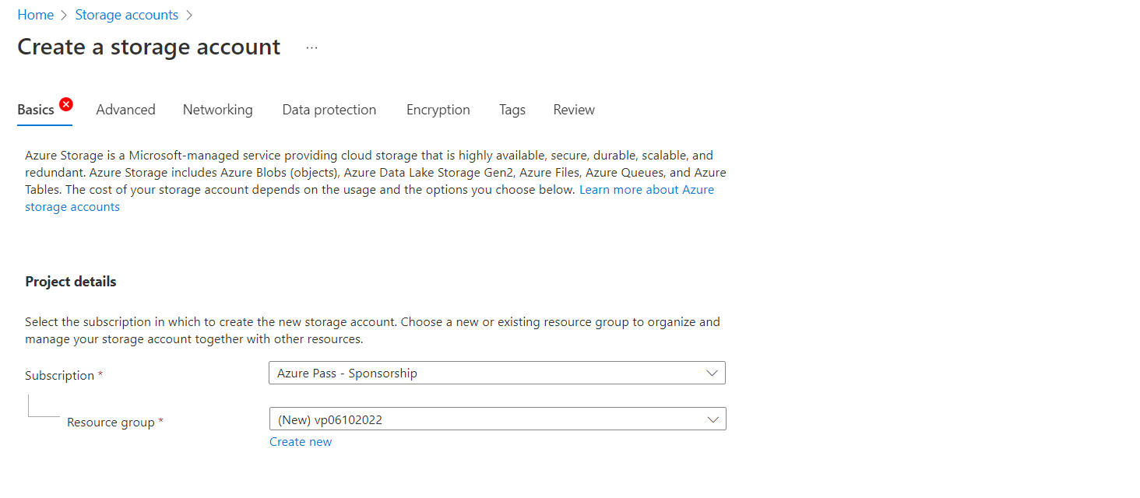

● Create a Storage account.

Step 1 : Open Storage account in azure portal @portal.azure.com/#home

Step 2 : Click on Create option to create a new storage account

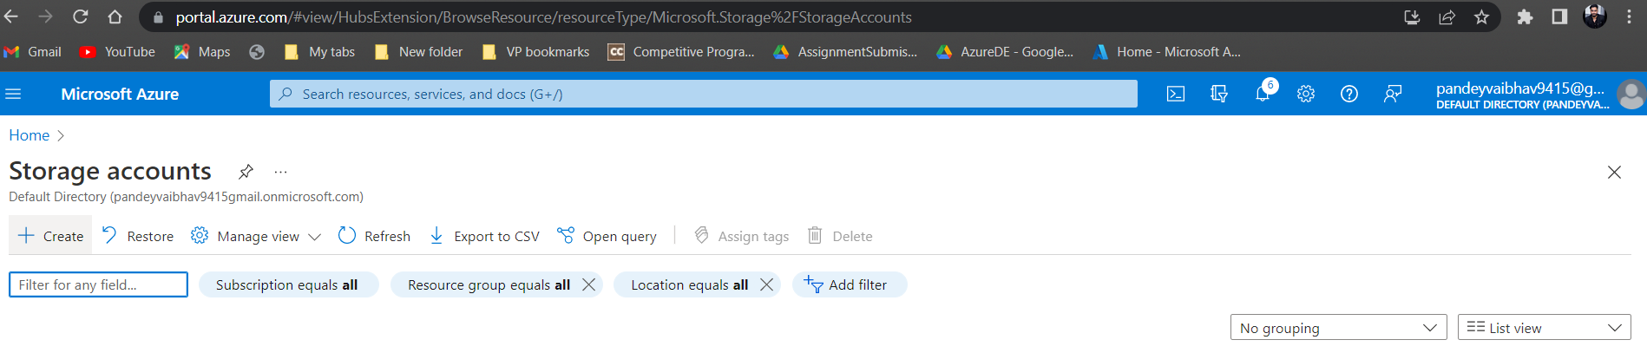

Select redundancy as ‘LRS’ and Performance as Standard

Check the “Enable Hierarchical space” box to ensure the account to be created as ADLSv2 storage.

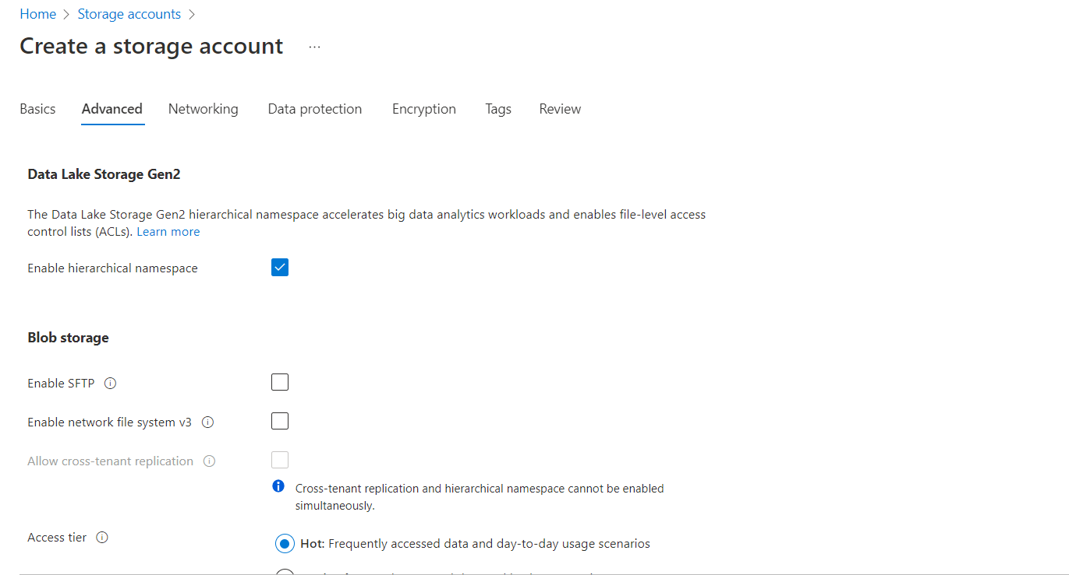

Keep “Encryption ” and “Tags” as Default . Then click on Create.

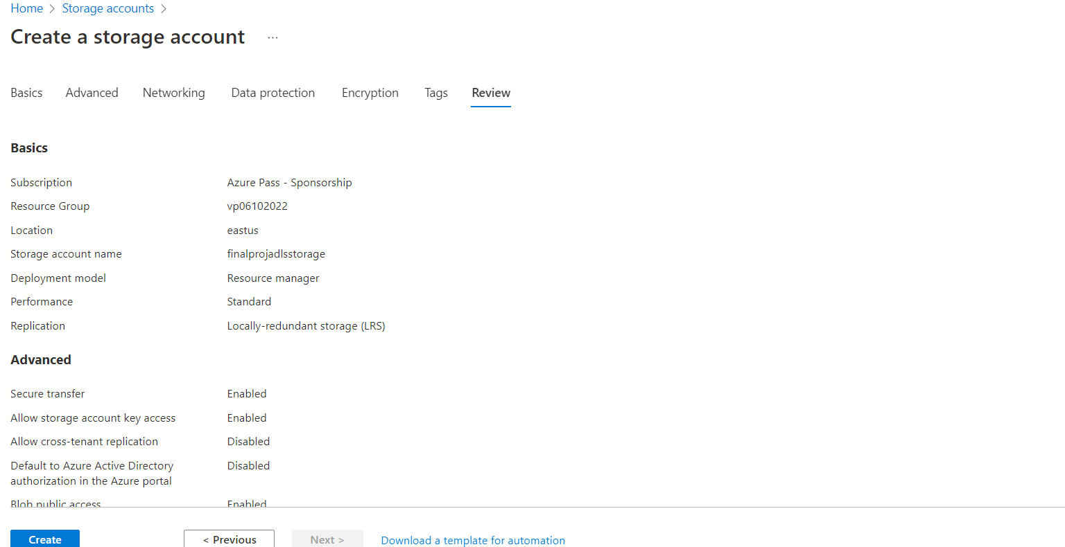

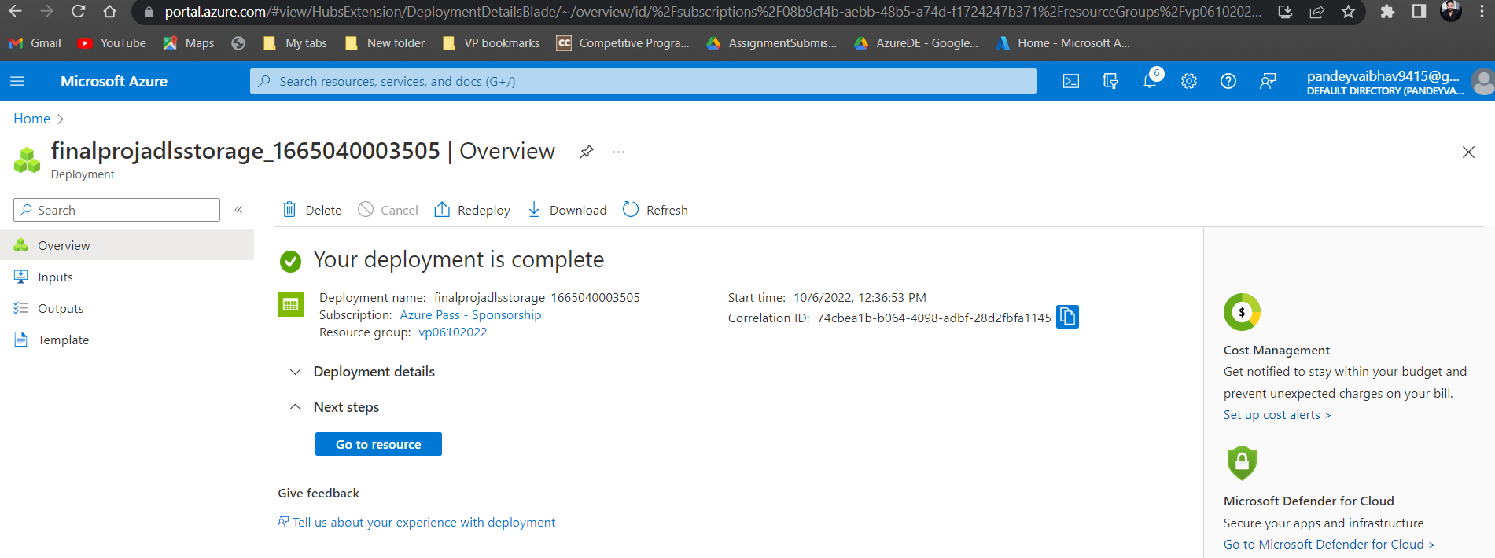

● Create an Azure SQL Database.

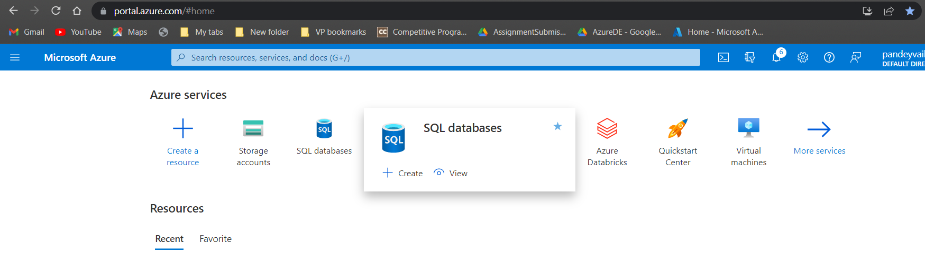

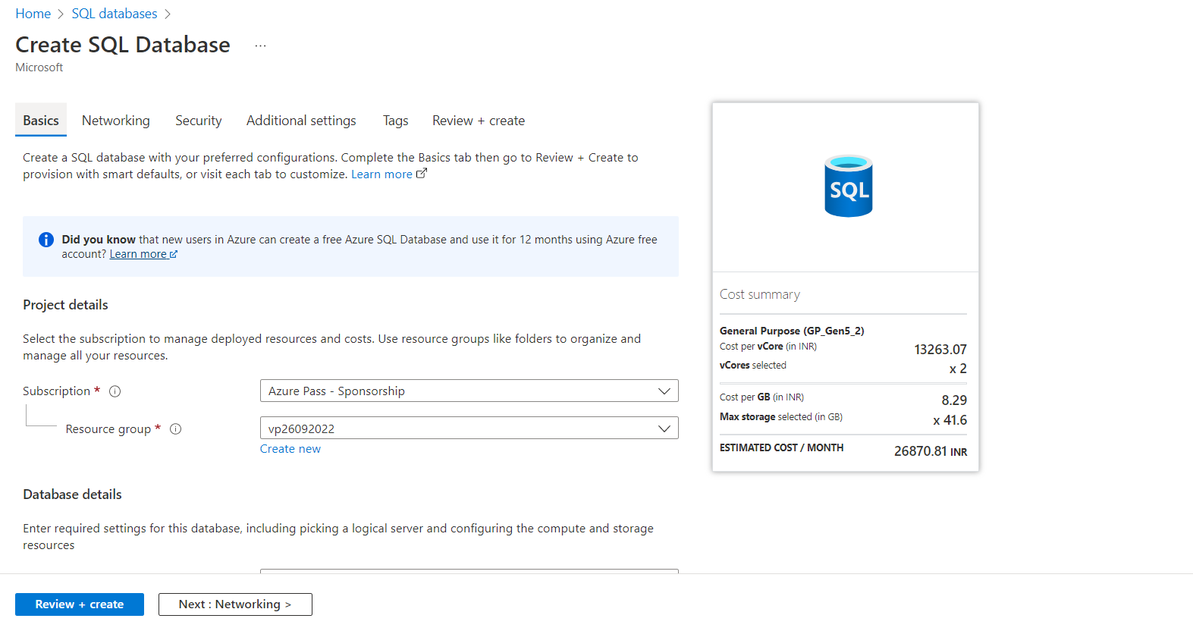

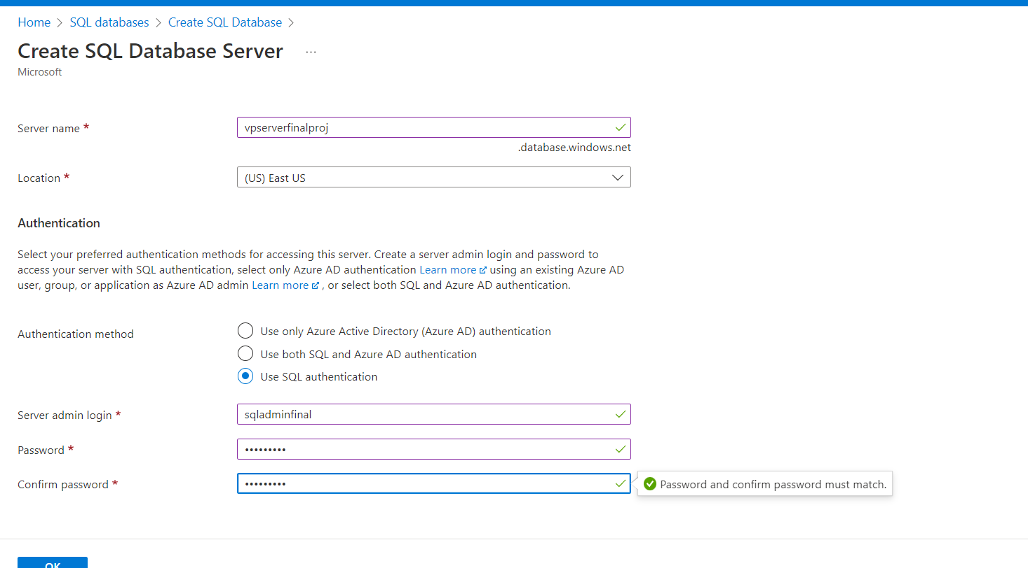

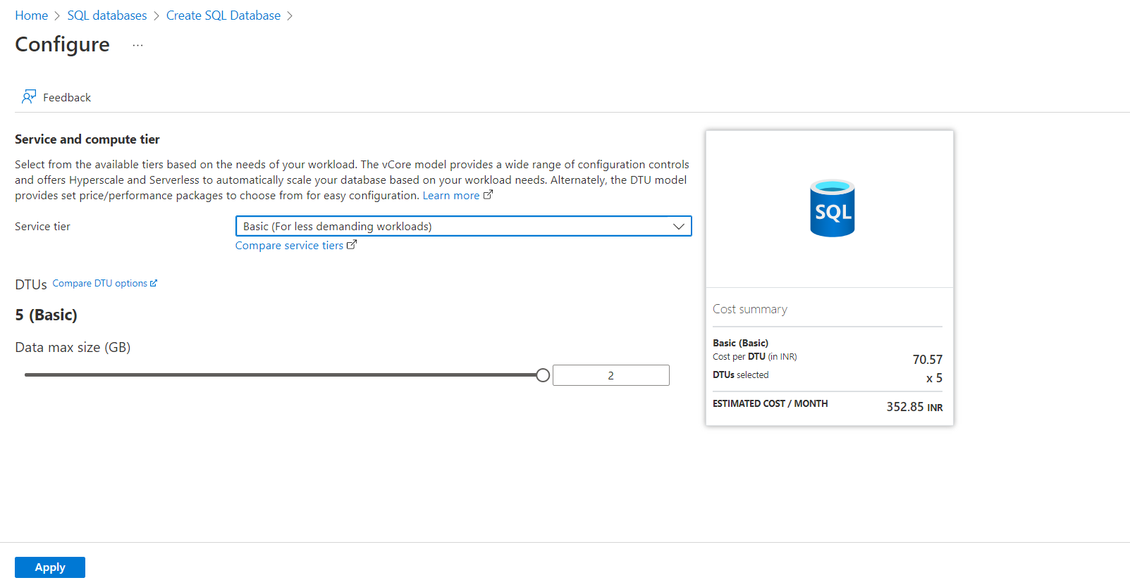

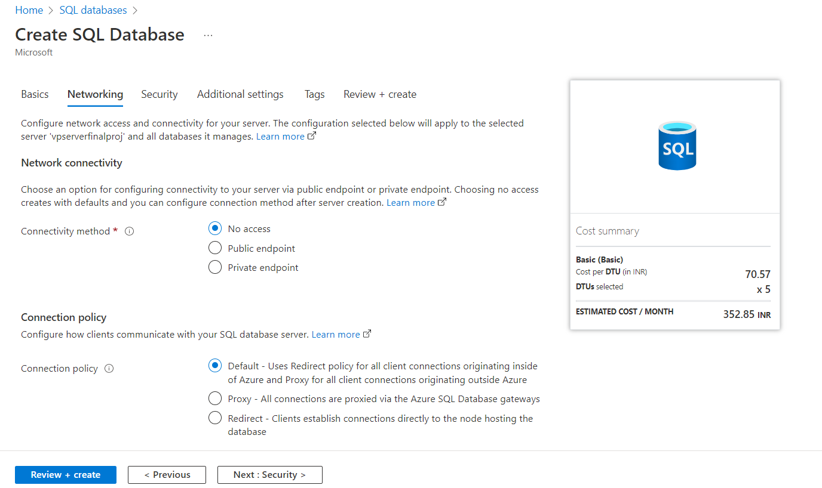

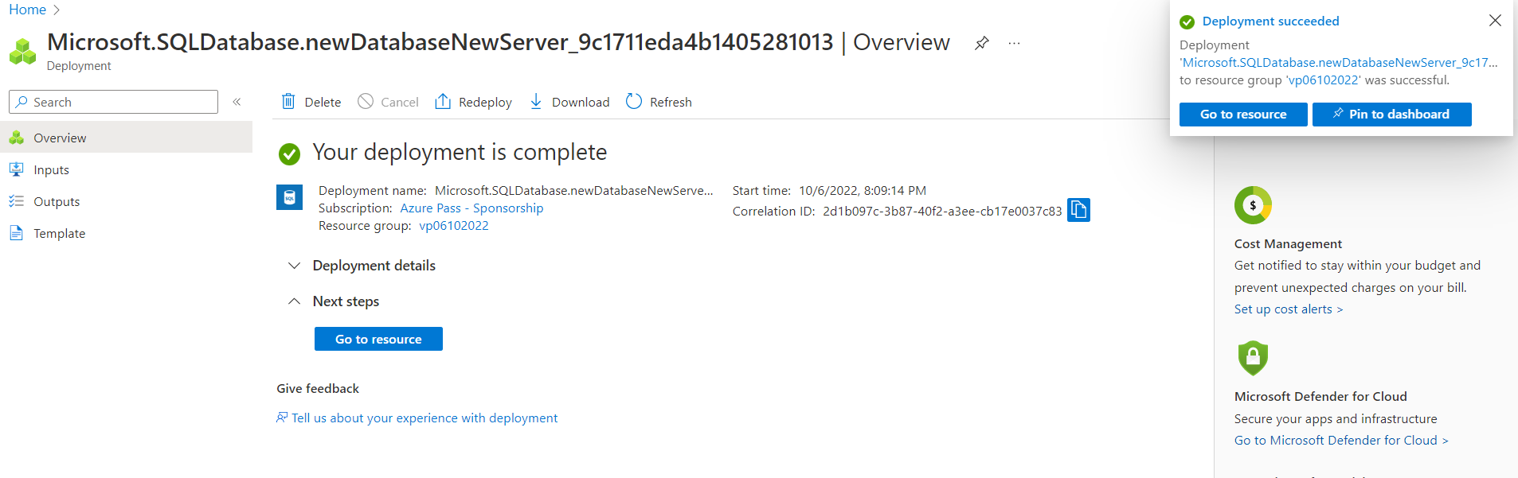

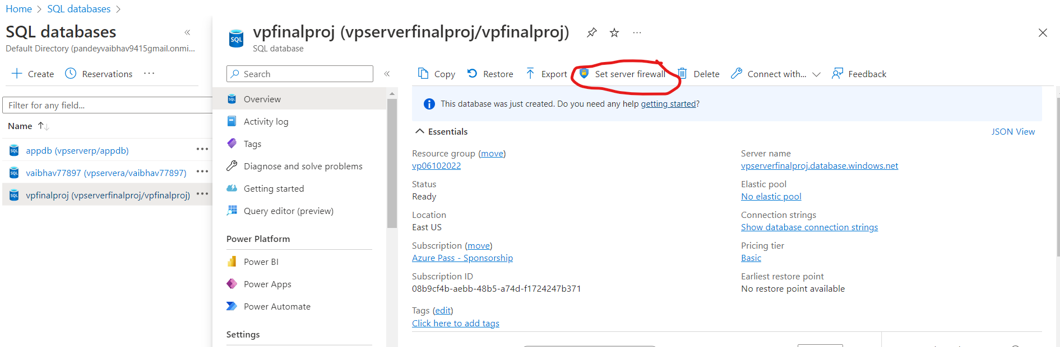

● Create a data factory.

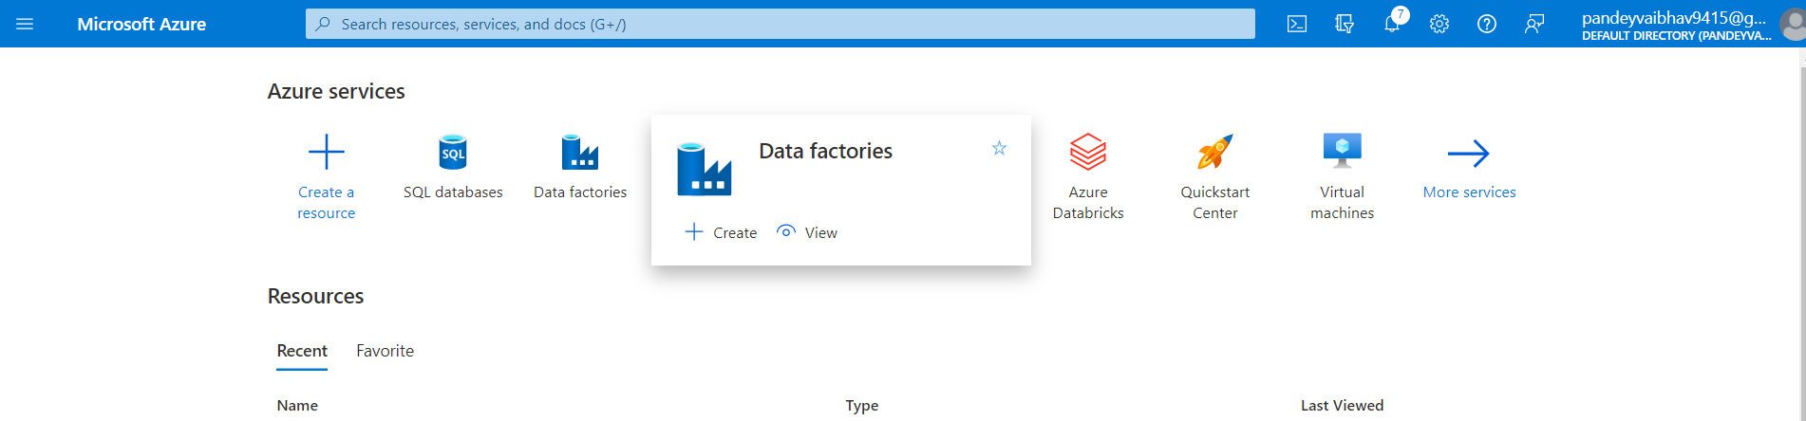

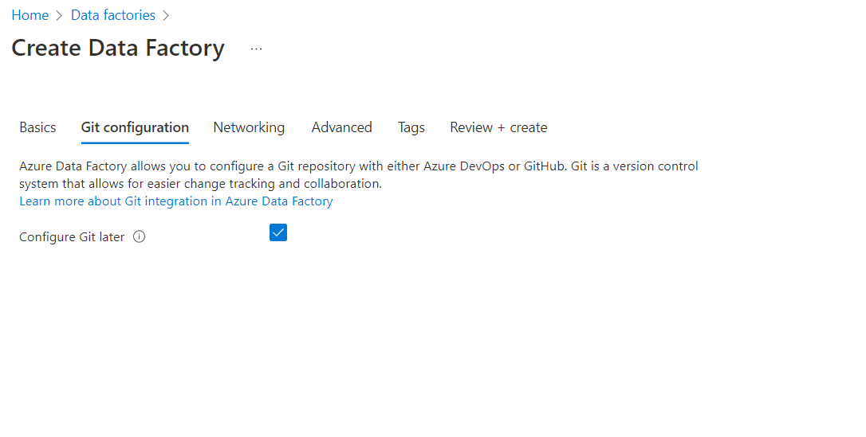

● Configure Databricks cluster

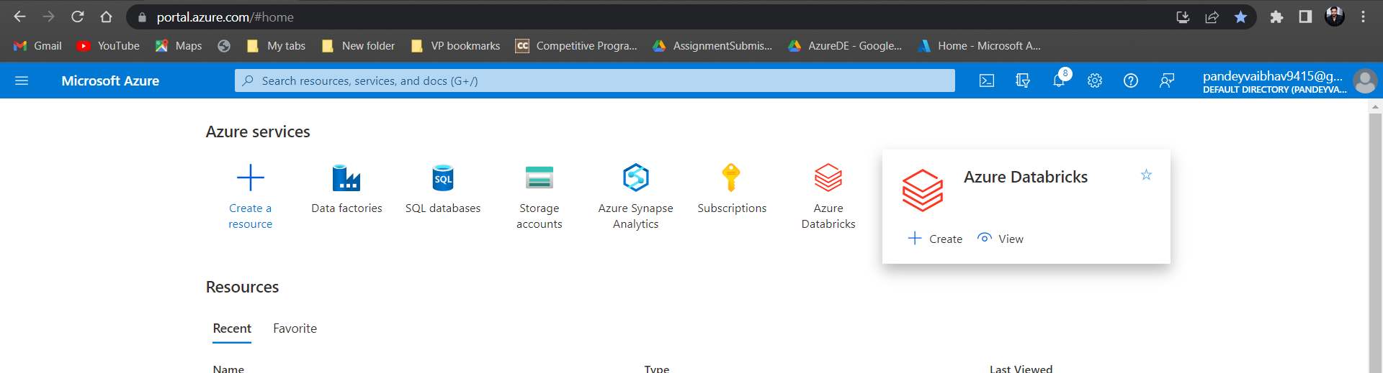

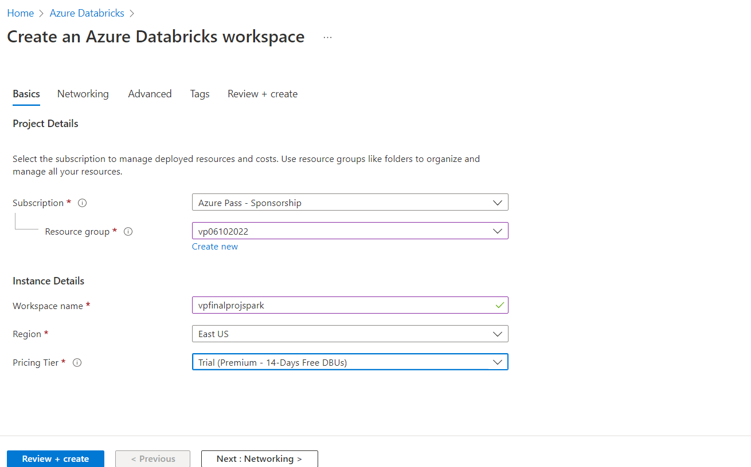

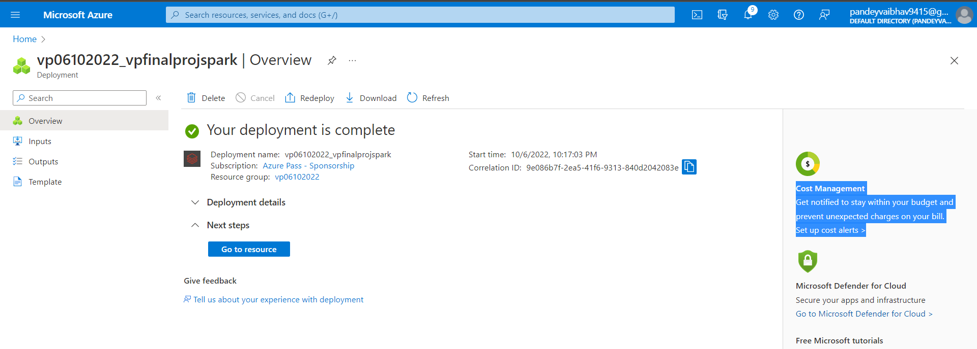

● Create Synapse analytics Data Warehouse.

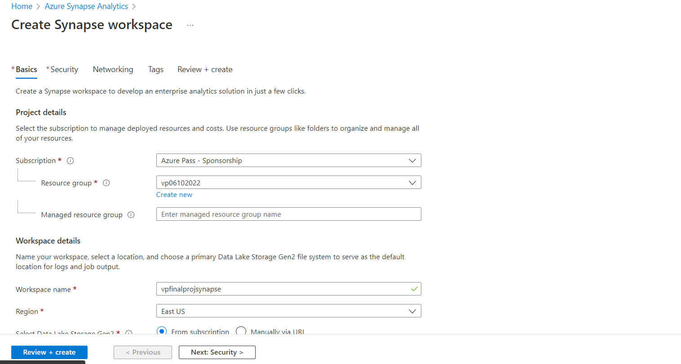

Default

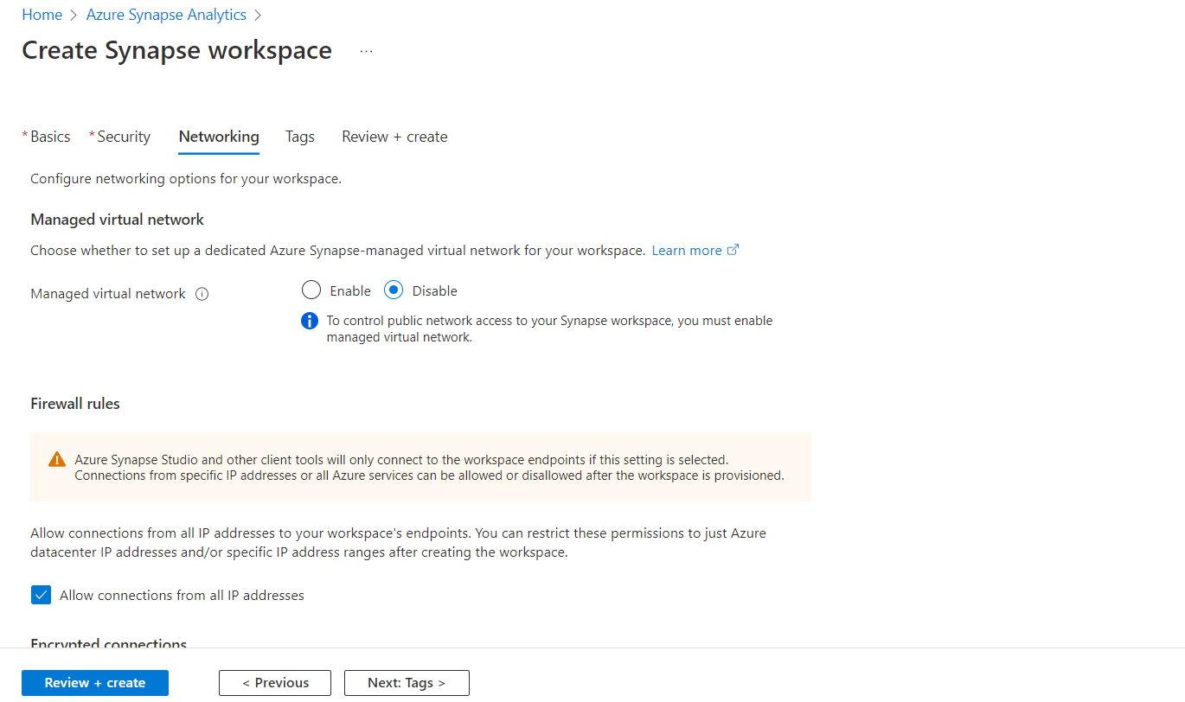

For making a dedicated SQL Pool

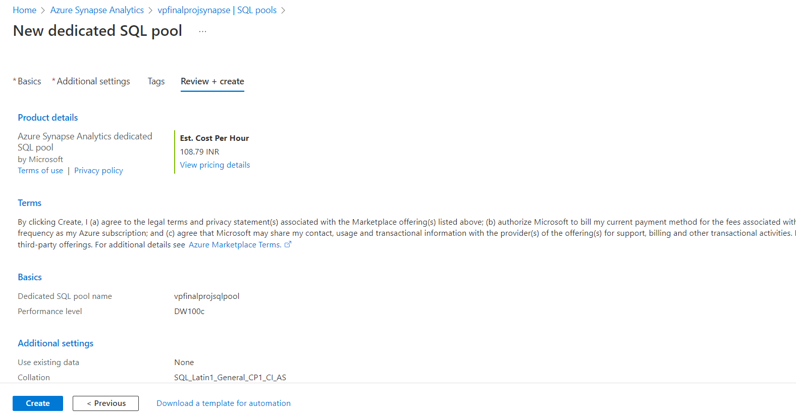

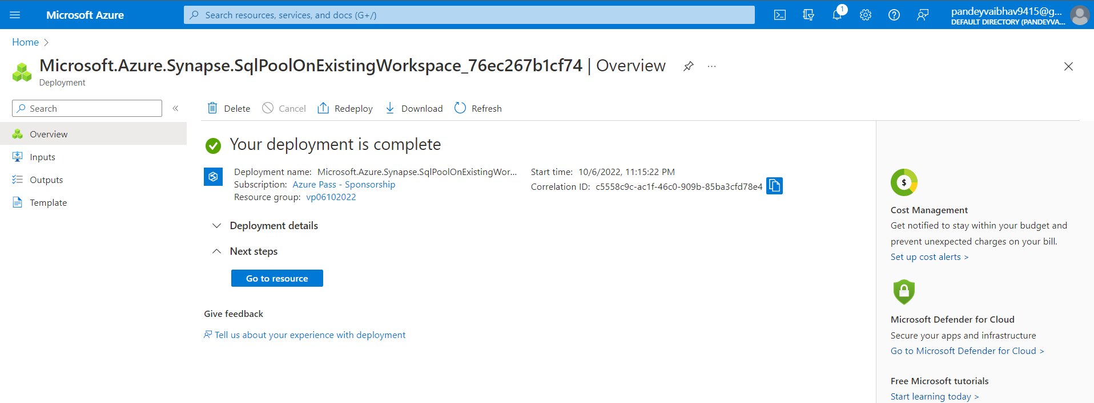

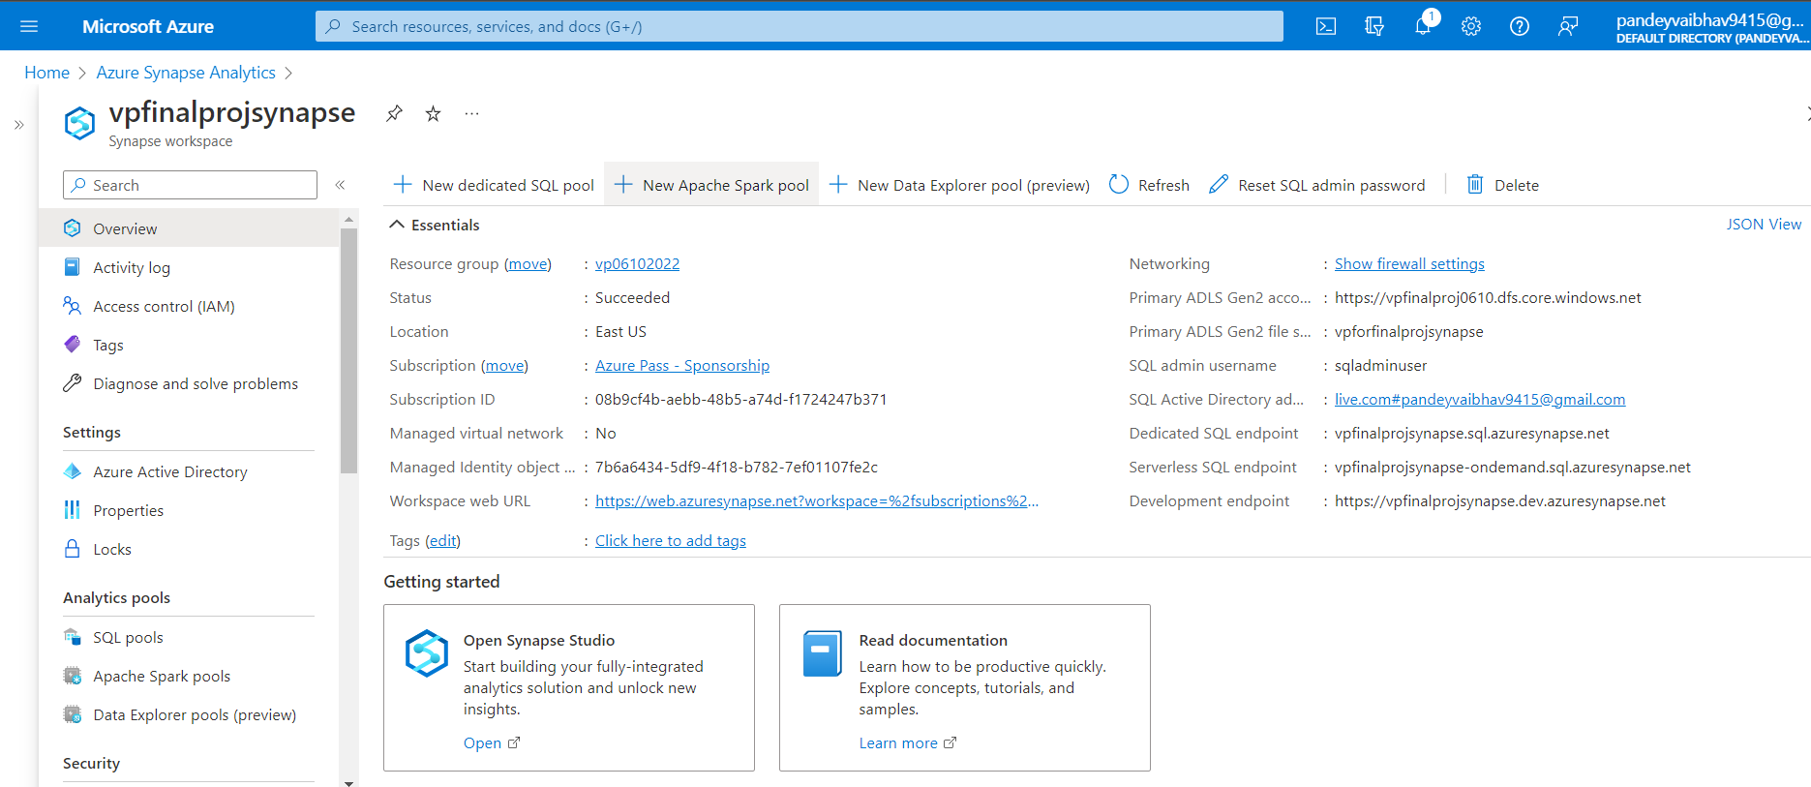



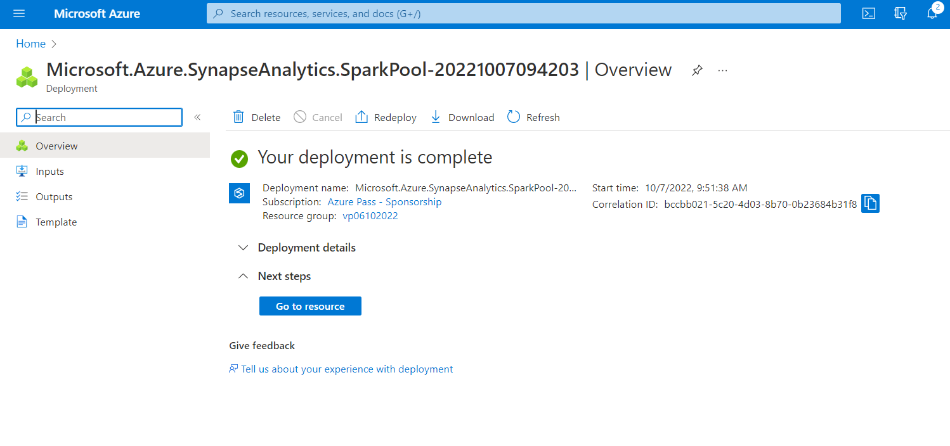

● Use the different Azure data factory tools to build a pipeline (SQL Database-> Copy->

ADLS Gen 2 -> Transform using Databricks -> Copy to Synapse DW).

● Use Databricks notebook for mounting ADLS Gen 2 storage, transforming the data

(clean, join, filter, aggregate, pivot) and persist result to ADLS.

● Schedule and Monitor the pipeline and activity runs.

Questions that need to be answered/Evaluation steps while

building the ETL Pipeline :

Task 1: Create a dataflow with the following requirement:

1. Create a data stream named CleaningGenreRomance and perform data cleansing on the Genre

column using Derived Column and case expression. (While collecting data it was observed that

some genres have spelling mistakes like romance, Romence for Romance, comedy, Comdy for

Comedy.)

Step 1 : First store movies data in ADLS storage account.

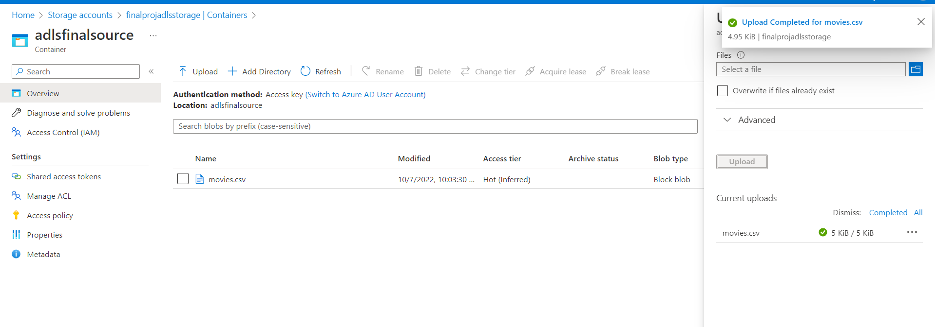

Now work on data flow

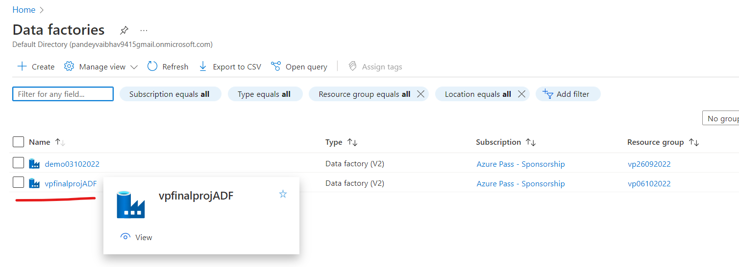

Now go for data cleansing:

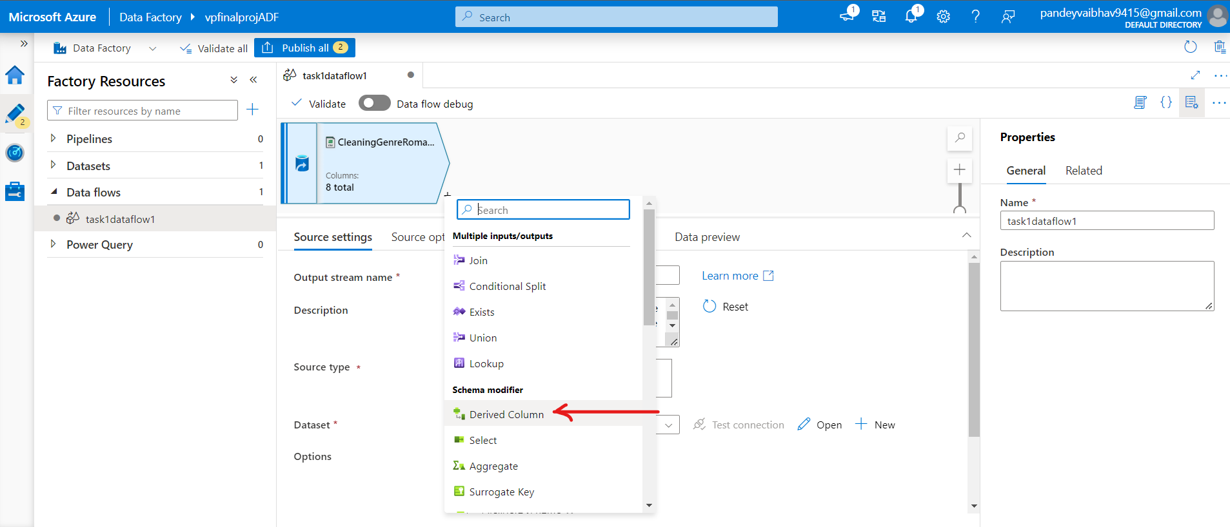

2. Create a data stream named CountMoviesBasedOnGenre that can calculate number of films for

each genre and store it as a separate dataset in ADLS under folder name “solution/genreCount”

3. Create a new stream named JoinMovieCountWithCleanData. Perform join operation on

CountMoviesBasedOnGenre with CleaningGenreRomance stream and store the same in the Azure

SQL Database.

Task 2: Create the following activity pipeline

1. Get the clean data from Azure SQL DB. Create an activity that can copy the data from SQLDB to

ADLS Gen2.

2. Create an activity that can use Azure Databricks to read the data from the ADLS Gen2 and perform

rank operation on the Genre column. Ensure this activity gets activated only after the data is stored

in ADLS from SQL DB. The result of Databricks must be stored in the ADLS.

3. Create a final activity that will read the output of previous activity in ADLS and store the same in

Synapse.